UMER HASSAN KHAN

SQL Server Built In Functions
ASCII
Returns the ASCII value for the specific character
CHAR
Returns the character based on the ASCII code
CHARINDEX
Returns the position of a substring in a string
CONCAT
Adds two or more strings together
Concat with +
Adds two or more strings together
CONCAT_WS
Adds two or more strings together with a separator
DATALENGTH
Returns the number of bytes used to represent an expression
DIFFERENCE
Compares two SOUNDEX values, and returns an integer value
FORMAT
Formats a value with the specified format
LEN
Returns the length of a string
LOWER
Converts a string to lower-case
QUOTENAME
Returns a Unicode string with delimiters added to make the string a valid SQL Server delimited identifier
REPLACE
Replaces all occurrences of a substring within a string, with a new substring
REPLICATE
Repeats a string a specified number of times
REVERSE
Reverses a string and returns the result
RIGHT
Extracts a number of characters from a string (starting from right)
SOUNDEX
Returns a four-character code to evaluate the similarity of two strings
SPACE
Returns a string of the specified number of space characters
STR
Returns a number as string
STUFF
Deletes a part of a string and then inserts another part into the string, starting at a specified position
SUBSTRING
Extracts some characters from a string
UNICODE
Returns the Unicode value for the first character of the input expression
UPPER
Converts a string to upper-case
ABS
Returns the absolute value of a number
ACOS
Returns the arc cosine of a number
ASIN
Returns the arc sine of a number
ATAN
Returns the arc tangent of a number
ATN2
Returns the arc tangent of two numbers
AVG
Returns the average value of an expression
CEILING
Returns the smallest integer value that is >= a number
COUNT
Returns the number of records returned by a select query
COS
Returns the cosine of a number
COT
Returns the cotangent of a number
DEGREES
Converts a value in radians to degrees
EXP
Returns e raised to the power of a specified number
FLOOR
Returns the largest integer value that is <= to a number
LOG
Returns the natural logarithm of a number, or the logarithm of a number to a specified base
LOG10
Returns the natural logarithm of a number to base 10
MAX
Returns the maximum value in a set of values
MIN
Returns the minimum value in a set of values
PI
Returns the value of PI
POWER
Returns the value of a number raised to the power of another number
RADIANS
Converts a degree value into radians
RAND
Returns a random number
ROUND
Rounds a number to a specified number of decimal places
SQUARE
Returns the square of a number
SUM
Calculates the sum of a set of values
TAN
Returns the tangent of a number
CURRENT_TIMESTAMP
Returns the current date and time
DATEADD
Adds a time/date interval to a date and then returns the date
DATEDIFF
Returns the difference between two dates
DATENAME
Returns a specified part of a date (as string)
DATEPART
Returns a specified part of a date (as integer)
DAY
Returns the day of the month for a specified date
GETDATE
Returns the current database system date and time
GETUTCDATE
Returns the current database system UTC date and time
ISDATE
Checks an expression and returns 1 if it is a valid date, otherwise 0
MONTH
Returns the month part for a specified date (a number from 1 to 12)
SYSDATETIME
Returns the date and time of the SQL Server
YEAR
Returns the year part for a specified date

SQL Server Advanced Functions
CAST
Converts a value (of any type) into a specified datatype
COALESCE
Returns the first non-null value in a list
CONVERT
Converts a value (of any type) into a specified datatype
CURRENT_USER
Returns the name of the current user in the SQL Server database
IIF
Returns a value if a condition is TRUE, or another value if a condition is FALSE
ISNULL
Return a specified value if the expression is NULL, otherwise return the expression
ISNUMERIC
Tests whether an expression is numeric
NULLIF
Returns NULL if two expressions are equal
SESSION_USER
Returns the name of the current user in the SQL Server database

JOINS
Inner Join
The INNER JOIN keyword selects records that have matching values in both tables.
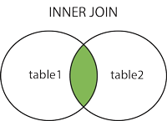

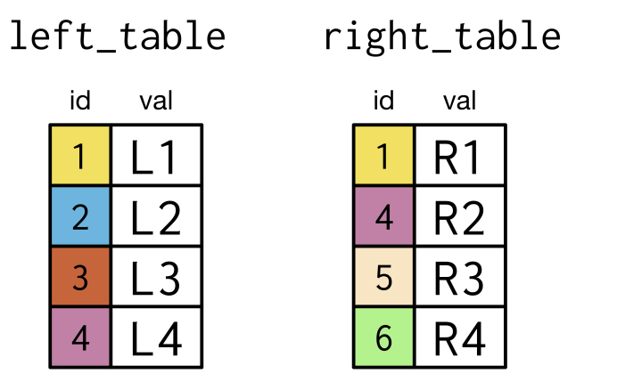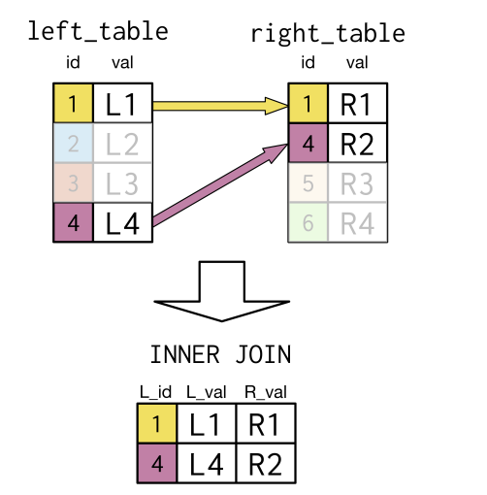
SELECT p1.id AS L_id, p1.val AS L_val, p2.val AS R_val
FROM left_table AS p1
INNER JOIN right_table AS p2
ON p1.id = p2.id;

SELF JOIN
A self join is a regular join, but the table is joined with itself.
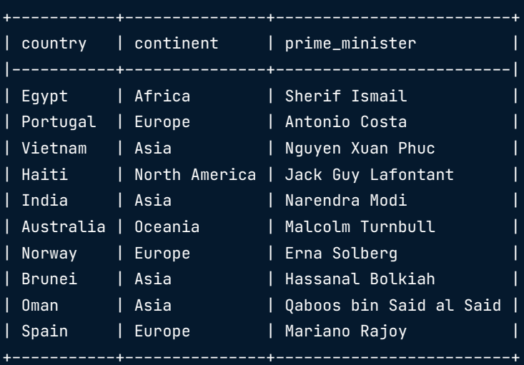
SELF JOIN EXAMPLE
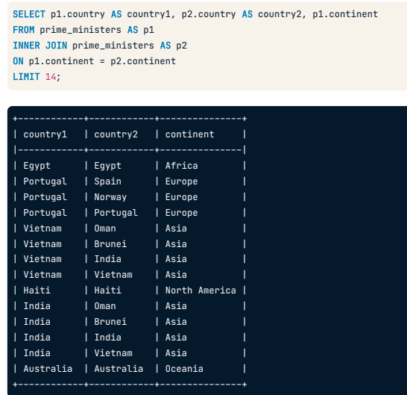

Left Join
The LEFT JOIN command returns all rows from the left table, and the matching rows from the right table. The result is NULL from the right side, if there is no match.
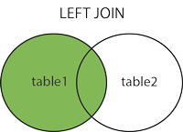

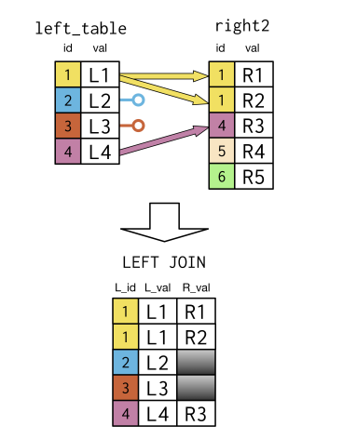
SELECT p1.id AS L_id, p1.val AS L_val, p2.val AS R_val
FROM left_table AS p1
LEFT JOIN right_table AS p2
ON p1.id = p2.id;

Right Join
The RIGHT JOIN keyword returns all records from the right table (table2), and the matching records from the left table (table1). The result is 0 records from the left side, if there is no match.
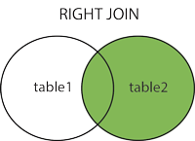


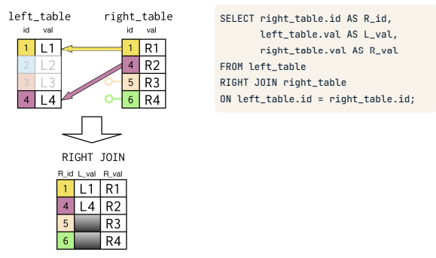

Full Join
The FULL OUTER JOIN keyword returns all records when there is a match in left (table1) or right (table2) table records.

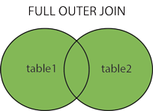


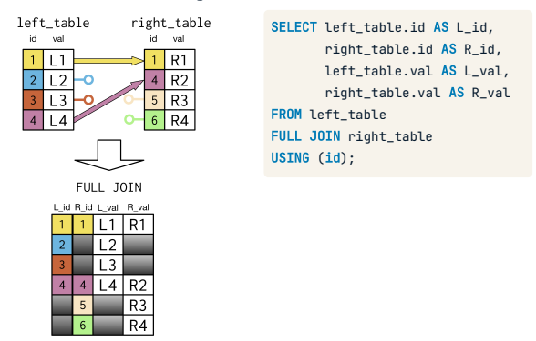

SQL unions
The UNION operator is used to combine the result-set of two or more SELECT statements.
- Every SELECT statement within UNION must have the same number of columns
- The columns must also have similar data types
- The columns in every SELECT statement must also be in the same order
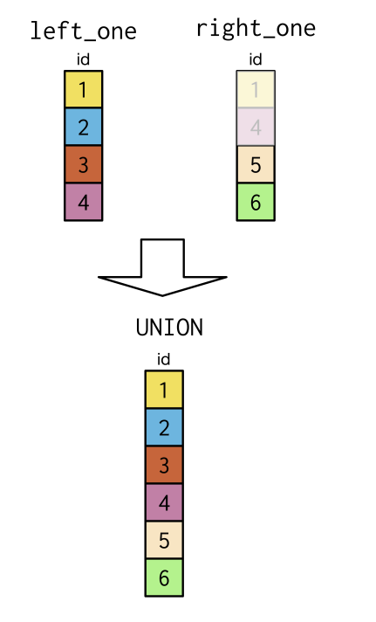

SELECT id
FROM left_one AS p1
UNION
SELECT id
FROM right_one AS p2
ORDER BY id

GROUP BY STATEMENT
The GROUP BY statement groups rows that have the same values into summary rows, like "find the number of customers in each country".
The GROUP BY statement is often used with aggregate functions (COUNT(), MAX(), MIN(), SUM(), AVG()) to group the result-set by one or more columns.
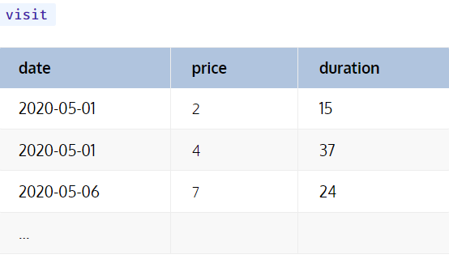
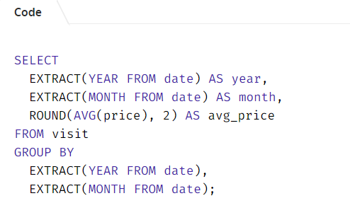
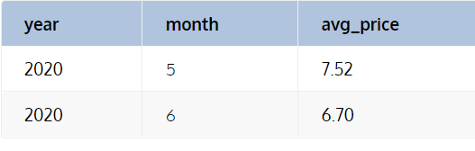
OVER()
The over clause combined with PARTITION BY is used to break up data into partitions. OVER clause defines a window or user-specified set of rows within a query result set.

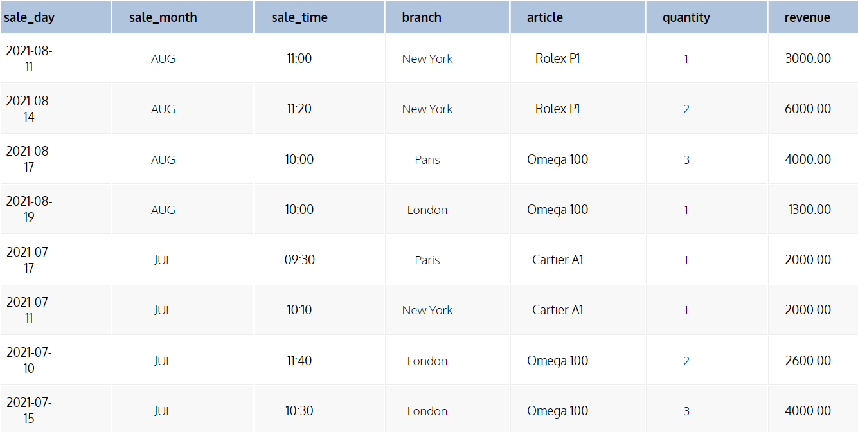
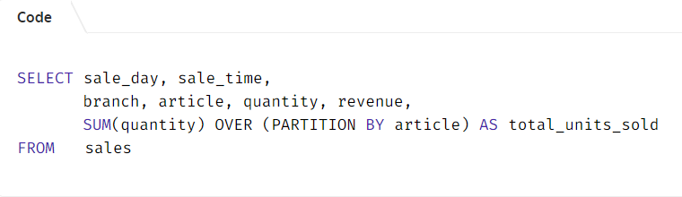
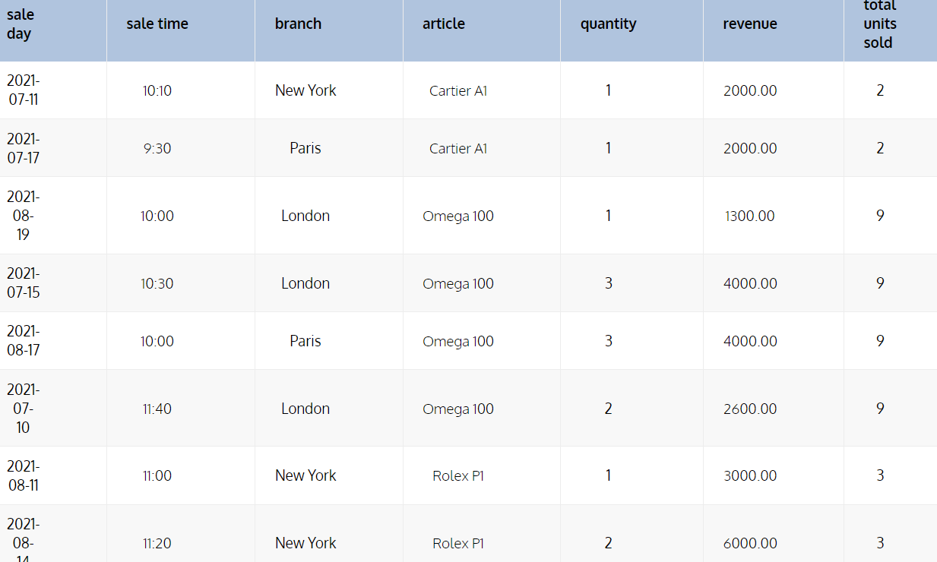

DDL (Data Definition Language):
DDL or Data Definition Language is a set of SQL commands used to create, modify, and delete database structures but not data. These commands are normally not used by a general user, who should be accessing the database via an application.
List of DDL commands:
CREATE: This command is used to create the database or its objects (like table, index, function, views, store procedure, and triggers).
DROP: This command is used to delete objects from the database.
ALTER: This is used to alter the structure of the database.
TRUNCATE: This is used to remove all records from a table, including all spaces allocated for the records are removed.
COMMENT: This is used to add comments to the data dictionary.
RENAME: This is used to rename an object existing in the database.

DQL (Data Query Language):
We can define DQL as follows it is a component of SQL statement that allows getting data from the database and imposing order upon it. It includes the SELECT statement. This command allows getting the data out of the database to perform operations with it. When a SELECT is fired against a table or tables the result is compiled into a further temporary table, which is displayed or perhaps received by the program i.e. a front-end.
List of DQL commands:
SELECT: It is used to retrieve data from the database.

DML (Data Manipulation Language):
The SQL commands that deals with the manipulation of data present in the database belong to DML or Data Manipulation Language and this includes most of the SQL statements. It is the component of the SQL statement that controls access to data and to the database.
List of DML commands:
INSERT: It is used to insert data into a table.
UPDATE: It is used to update existing data within a table.
DELETE: It is used to delete records from a database table.
LOCK: Table control concurrency.
CALL: Call a PL/SQL or JAVA subprogram.
EXPLAIN PLAN: It describes the access path to data.

Subqueries
A subquery is a SQL query nested inside a larger query.
- A subquery may occur in :
  - - A SELECT clause
  - - A FROM clause
  - - A WHERE clause
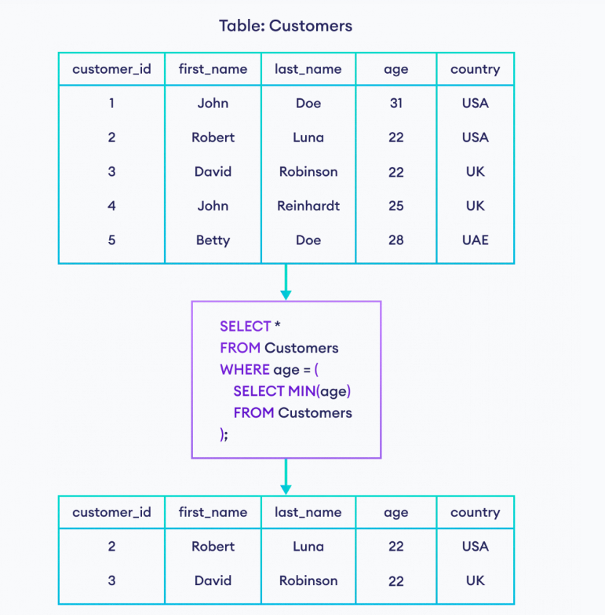

Views:
A view is nothing more than a SQL statement that is stored in the database with an associated name. A view is actually a composition of a table in the form of a predefined SQL query.
A view can contain all rows of a table or select rows from a table. A view can be created from one or many tables which depends on the written SQL query to create a view.
Views, which are a type of virtual tables allow users to do the following −
- Structure data in a way that users or classes of users find natural or intuitive.
- Restrict access to the data in such a way that a user can see and (sometimes) modify exactly what they need and no more.
- Summarize data from various tables which can be used to generate reports.

StudentDetails
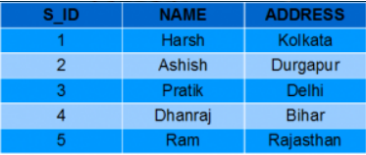
StudentMarks
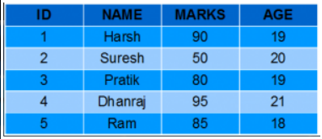
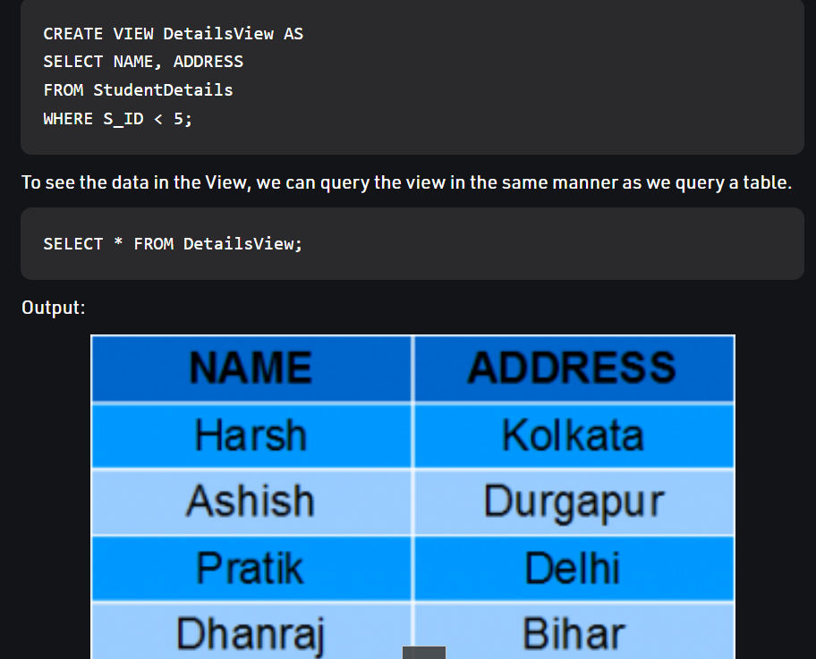

Syntax for deleting views:
DROP VIEW view_name;

Syntax for updating views:
CREATE OR REPLACE VIEW MarksView AS
SELECT StudentDetails.NAME, StudentDetails.ADDRESS, StudentMarks.MARKS, StudentMarks.AGE
FROM StudentDetails, StudentMarks
WHERE StudentDetails.NAME = StudentMarks.NAME;
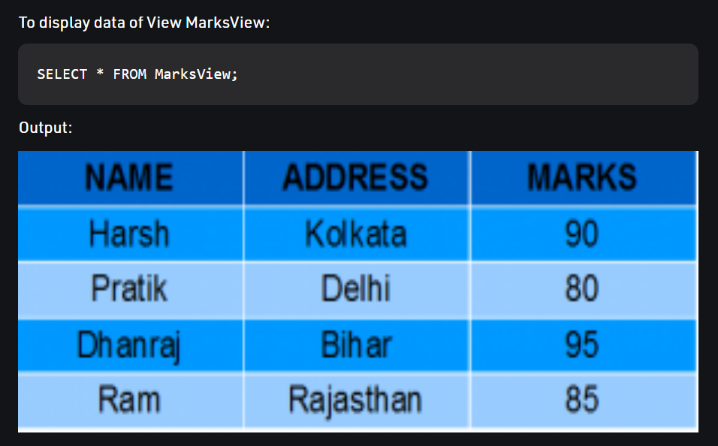

Stored Procedure
A stored procedure is a prepared SQL code that you can save, so the code can be reused over and over again.
So if you have an SQL query that you write over and over again, save it as a stored procedure, and then just call it to execute it.
You can also pass parameters to a stored procedure, so that the stored procedure can act based on the parameter value(s) that is passed.
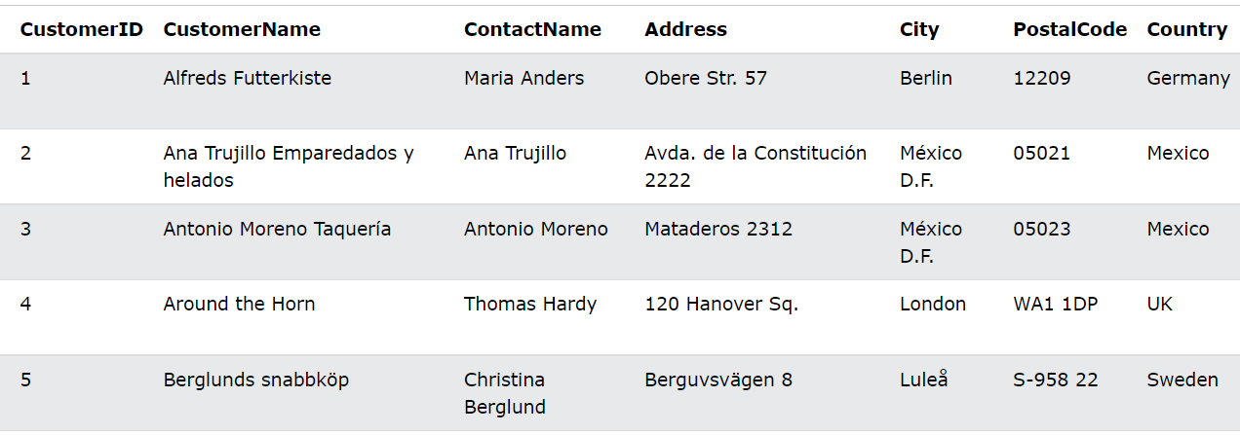
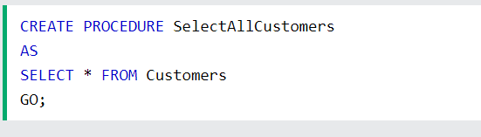

Stored Procedure With Multiple Parameters
